London Baptist News

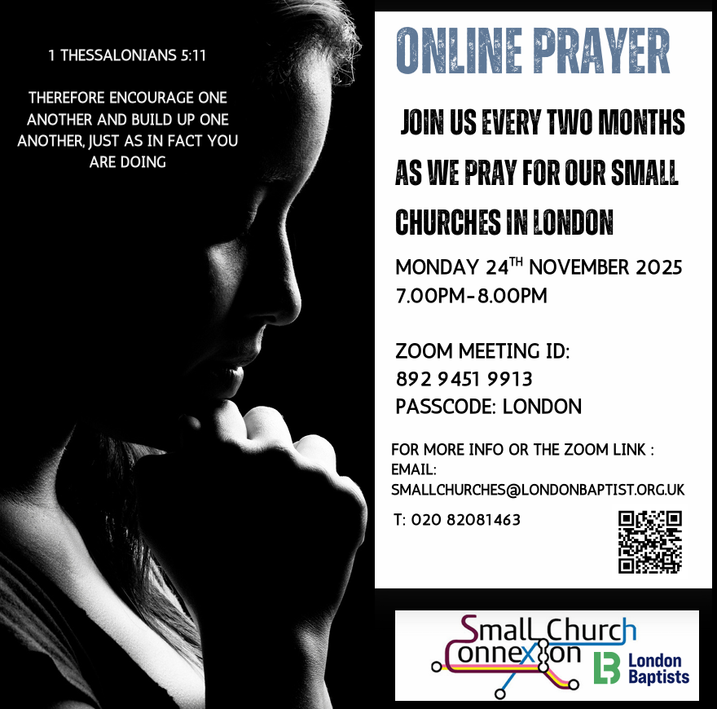


Baptist Assembly: Friday, 15 – Sunday, 17 May 2026 at the Harrogate Convention Centre, discounted early bird tickets of £125 for adults are available until the end of November 2025. After November, the cost will be £139.00. Children and young people are free of charge. Go to the Baptist Union website for more details and to book.

 The Intercultural Church and City Transformation Gathering - 5 - 6 February 2026 Join leaders from across the UK in Manchester on 5–6 February 2026, for the Intercultural Church and City Transformation (ICCT) Gathering. Centred on Imago Dei – Made in the Image of God, the event features dynamic speakers, intercultural worship, and four learning tracks, equipping churches and communities to live out unity, justice, and transformation in diverse contexts.



Welcome to
Willesden Green Baptist Church
23rd November 2025

Services: 11am and 6.30pm
Weekly Meetings
Mondays – 7.30pm – 9pm – Bible Study and Prayer Meeting led by Elizabeth Amenuvor.
Mondays - 6pm – 7pm - Sis Sheilah’s Weekly Bible Study on the telephone.
Suspended until further notice.
Tuesdays – 7.30pm – 9pm – Bible Study and Prayer Meeting led by Andrea Marc. Their Christmas break starts on 16th December and they resume on 13th January 2026.
Thursdays – 1.30pm – 3.30pm – Thursday Bible Study led by Janice Carrington.
Thursdays – 6.30pm – 8pm – Prayer Meeting and Bible Study.
Fridays – 5pm to 7pm every two weeks - Open House
Gospel Café – suspended until further notice.
Church Secretary: Lorna Anderson-Edwards
Church Treasurer: Les Ale
Church Administrator: Deborah Hayward
Church Office: 020 8451 4951
Website: www.wgbc.london Email: office@wgbc.london Charity Number: 1135448
Willesden Green Baptist Church, 94 High Road Willesden Green, NW10 2PR

Autumn Term
Theme: The Child Messiah Born to Reign forever on David’s Throne
Text: “And the Government shall be upon His shoulders” Isaiah 9: 6

Today, 23rd November, the theme will be “Mary’s Song for the Special Child”
Bible Reading: Luke 1: 46 – 56 read by Sam Okore
Preacher: Rev Stephen Maclean, our Moderator
Worship Leader: Godwin
Service Leader: Janice Carrington

Next week, 30th November, is the first Sunday in Advent. The theme will be “The Word became Flesh”.
Bible Reading: John 1: 14 – 18 read by Bunmi Bajela
Preacher: Bro Edward Boamah
Worship Leader: Janice Carrington
Service Leader: Awa Matashi

Our Bank Details
Bank: The Co-operative Bank
Account Name: Willesden Green Baptist Church.
Account No: 6736 0194
Sort Code: 08-92-99
Please quote GAxxx as your reference (where xxx represents your three-digit gift
aid number). If you don’t have a Gift Aid number, please contact the Treasurer,
Les Ale on 07940 537418 or via e-mail at church_treasurer@wgbc.london

Please remember to take your notice sheets with you after the service so you can keep up to date with the church activities. Also, please dispose of any rubbish you have with you in the bins provided. Thank you.

Sunday Service Audios
If you want to listen to the services when you are unable to attend in person, please contact Bro Emmanuel on 07956 484808 and ask him to put your name on the WhatsApp list to receive the service on your mobile phone.

Volunteers Needed
- Volunteers are needed for the Open House Christmas Party on Friday 12th December. Contact Ifure Ibanga on 07517 348184 for more information.
- Volunteers are also needed for stewarding and other roles. Contact the church office.
- If you want to borrow any item from the church, please ask one of the Deacons for permission. Then contact the Church Administrator. Failure to do so will result in you being charged the full market value of the item you borrowed.

Fellowship News
Please continue to pray for those struggling with illness especially: -
Sisters: Comfort A; Lydia B, Edna B, Marie B, Cynthia C, Melva F, Dorothy G, Marjorie G; Mavis H, Avril J, Cloedine K, Mariss M, Daphne M, ; Betty O-T, Ethel P, Sheilah P, Brothers Ebenezer A, Vernal B, Ron C, Winston E, Eric McL, Herbert T, Hubert J.

Please contact members who you have not seen in church for some time. If you do not have their telephone number, or want a pastoral visit yourself, please contact the church office.
Prayer
*Please pray for the church in this time of transition.
*Please pray for the leadership of this church.
*Please pray for Sis Melvina Ennis’s family as she died on 17th October.
*Please pray for Sis Beatrice Williams’ family as she died on 10th November. Her funeral will be on Thursday 11th December 2025 at 11am. The reception will be at this church after the internment
*Please pray for Sis Carmelita O’Sullivan’s family as she died on 13th November 2025.
*Please pray for Sis Neva Evans’s family as she died on 14th November.



God’s blessing to everyone who has a Birthday or Anniversary this week.
God bless you on your special day and every day.

Forthcoming Events
Deacons Meeting: today, 23rd November 2025, after morning service.
AGM: 30th November 2025 after morning service.

Christmas Services
Carols by Candlelight Service – Sunday 21 December - 6.30pm;
Christmas Eve – Wednesday 24 December – 8pm to 9pm,
Christmas Day - Thursday 25 December 10am to 11am;
Watch Night Service - Wednesday 31 December - 10pm to 12.30am 1 January 2026.

