London Baptists Events



Baptist Assembly: Friday, 15 – Sunday, 17 May 2026 at the Harrogate Convention Centre. Cost will be £139.00. The price does not include accommodation. Children and young people are free of charge. Go to the Baptist Union website for more details and to book.


Date: 21 May 2026
Time: 11:00am - 12:00pm
Venue: Zoom Event
Come and Hear How...
"The Church Can Exceedingly Multiply by Reaching Out to the Community"
Samuele Aru, Lead Pastor and Founder of Living Church, will be sharing the principles and strategies that led to an extraordinary season of growth and transformation in his church.
e-mail hany.abdelmasih@londonbapitst.org.uk for more information and to sign up.

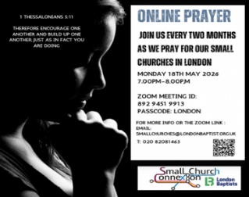

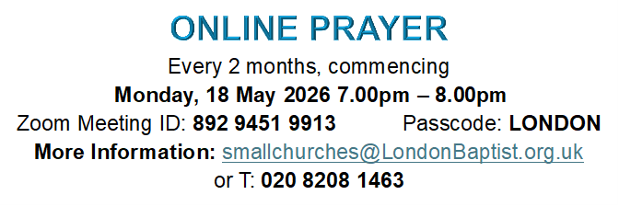



Welcome to
Willesden Green Baptist Church

10th May 2026
Services: 11am and 6.30pm

Weekly Meetings
Tuesdays – 7.30pm – 9pm – Bible Study and Prayer Meeting led by Andrea Marc.
Tuesdays – 7.30pm – 9pm – Bible Study and Prayer Meeting led by Elizabeth Amenuvor (Bi-weekly)
Wednesday – 11am – 12.30pm – Discipleship and Bible Class led by Pastor Petueli Inoke.
Thursdays – 1.30pm – 3.30pm – Thursday Bible Study led by Janice Carrington.
Thursdays – 6.30pm – 8pm – Corporate Prayer Meeting and Bible Study.
Fridays – 5pm to 7pm every two weeks - Open House. Next session: 22nd May 2026.
Saturdays - 13:00 to 15:00 – Gospel Café. Led by Bro Emmanuel Mpaka.

Church Secretary: Lorna Anderson-Edwards
Church Treasurer: Les Ale
Church Administrator: Deborah Hayward
Church Office: 020 8451 4951
Website: www.wgbc.london Email: office@wgbc.london Charity Number: 1135448
Willesden Green Baptist Church, 94 High Road Willesden Green, NW10 2PR

Spring Term
Theme: People of Praise and Worship
Text: “And Let us consider how we may spur one another on toward Love and Good Deeds” Hebrews 10: 24

May Theme: I have set you as a Light to the Gentiles”

Today, 10th May, the theme will be “A Cheerful Giver”.
Bible Reading: 2 Corinthians 9: 6 – 11 read by Les Ale
Preacher: Pastor Eyasu
Worship Leader: The Seraph Choir
Service Leader: Emmanuel Mpaka

Next week, 17th May, the theme will be “Act upon the World”
Bible Reading: John 6: 1 – 13 read by Sam Okore
Preacher: Bro Eric Thorn
Worship Leader: Mimi Thorn
Service Leader: Bunmi Oguntunde
The service will include Holy Communion and there will be an additional collection for the Fellowship Fund during the service.

Our Bank Details for Tithes and Offerings
Bank: The Co-operative Bank
Account Name: Willesden Green Baptist Church.
Account No: 6736 0194 Sort Code: 08-92-99 Please quote GAxxx as your reference (where xxx represents your three-digit gift aid number). If you don’t have a Gift Aid number, please contact the Treasurer, Les Ale on 07940 537418 or via e-mail at church_treasurer@wgbc.london

Sunday Service audios To receive a recording of the service on your mobile phone contact Bro Emmanuel on 07956 484808 and ask him to add your name to the WhatsApp list.

Deacons needed. If you know God is calling you to serve Him as a deacon, please contact Sis Lorna Anderson-Edwards (The Church Secretary) for more details and how to be nominated.
Volunteers Needed
- Volunteers are needed for stewarding and other roles. Contact the church office.
- If you want to borrow any item from the church, please ask one of the Deacons for permission. Then contact the Church Administrator. Failure to do will result in you being charged the full market value.

The church office is open from 10am to 3pm Monday to Friday
Fellowship News
Please continue to pray for those struggling with illness especially: -
Sisters: Comfort A; Lydia B, Edna B, Marie B, Cynthia C, Melva F, Dorothy G, Marjorie G; Mavis H, Cloeadene K, Mariss M, Daphne M ; Comfort O; Betty O-T, Ethel P, Sheilah P, Sandra W; Brothers Ebenezer A, Vernal B, Ron C, Winston E, Eric McL, Herbert T, Hubert J.

Please contact members who you have not seen in church for some time. If you do not have their telephone number, or want a pastoral visit yourself, please contact the church office.
Prayer
*Please pray for the church in this time of transition.
*Please pray for the leadership of this church, as they progress through the recruitment process for a new minister.
*Please pray for all who have lost loved ones recently.
**Please pray for Sis Orisa O and her family as her father has died recently.


To all celebrating a birthday or anniversary this month, we pray God’s abundant blessings over you and wish you a very special day.

Forthcoming Events
Ascension Day Special Prayer and Praise Meeting - Thursday 14th May from 7pm. Please note the usual weekly bible study and prayer meetings for that week will be suspended.
Deacons Meeting – Sunday 24th May
Members Meeting – Sunday 31st May
Worship Training Conference – Saturday 23rd May 2026 from 9.30am – 3.30pm at West Hendon Baptist Church. Book via Eventbrite or scan the QR code on the poster on the notice board in the foyer.
An Evening of Worship at West Hendon Baptist Church from 6pm on Saturday 23rd May. Scan or click the QR code on the poster in the foyer for a free ticket. Flyers are also available in the foyer for both the conference and evening of worship.
Pentecost & Members’ Meeting - Sunday 24th May
Men’s Conference “Digging Deeper” – 9.30am to 3.30pm on Saturday 13th June 2026 at Pinner Baptist Church. £10 including Indo-Sri Lankan Lunch. Book via Eventbrite. Places are limited. See poster on notice board for more information.

