London Baptist News

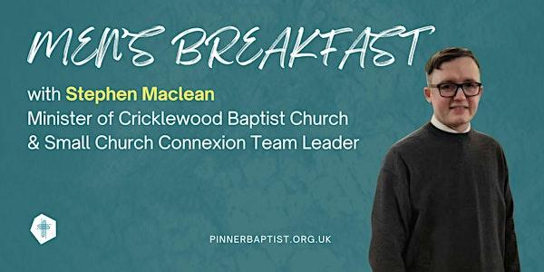

Men's Breakfast at Pinner Baptist Church on Saturday 7th February from 9-11am,
£10.00 per person.
Tickets available on Eventbrite


Baptist Assembly: Friday, 15 – Sunday, 17 May 2026 at the Harrogate Convention Centre. Cost will be £139.00. The price does not include accommodation. Children and young people are free of charge. Go to the Baptist Union website for more details and to book.



Welcome to
Willesden Green Baptist Church
25th January 2026

Services: 11am and 6.30pm
Weekly Meetings
Mondays – 7.30pm – 9pm – Bible Study and Prayer Meeting led by Elizabeth Amenuvor.
Tuesdays – 7.30pm – 9pm – Bible Study and Prayer Meeting led by Andrea Marc.
Thursdays – 1.30pm – 3.30pm – Thursday Bible Study led by Janice Carrington.
Thursdays – 6.30pm – 8pm – Prayer Meeting and Bible Study.
Fridays – 5pm to 7pm every two weeks - Open House. Next session: 30th January 2026

Church Secretary: Lorna Anderson-Edwards
Church Treasurer: Les Ale
Church Administrator: Deborah Hayward
Church Office: 020 8451 4951
Website: www.wgbc.london Email: office@wgbc.london Charity Number: 1135448
Willesden Green Baptist Church, 94 High Road Willesden Green, NW10 2PR
Winter Term
Theme: Building a true People of Praise, Purpose and Power
Text: “See I am sending an Angel ahead of you to guard you along the way and to bring you into the place I have prepared for you”. Exodus 23:20 (NIV)

Today, 25th January, the theme will be “Catching A Vision”.
Bible Reading: 2 Kings 4: 1 – 7 read by Catherine Morris
Preacher: Bro Edward Boamah
Worship Leader: Janice Group
Service Leader: Janice Carrington

Next week, 1st February, is our Church’s 144th Anniversary. The theme will be “Practicing True Love”.
Bible Reading: Romans 12: 9 – 21 read by Norma Jones
Preacher: Guest Speaker
Worship Leader: The Cherubs
Service Leader: Bunmi Oguntunde

Our Bank Details
Bank: The Co-operative Bank
Account Name: Willesden Green Baptist Church.
Account No: 6736 0194
Sort Code: 08-92-99
Please quote GAxxx as your reference (where xxx represents your three-digit gift
aid number). If you don’t have a Gift Aid number, please contact the Treasurer,
Les Ale on 07940 537418 or via e-mail at church_treasurer@wgbc.london

Sunday Service Audios
If you want to listen to the services when you are unable to attend in person, please contact Bro Emmanuel on 07956 484808 and ask him to put your name on the WhatsApp list to receive the service on your mobile phone.

Please remember to take your notice sheets with you after the service so you can keep up to date with the church activities. Also, please dispose of any rubbish you have with you in the bins provided. Thank you.
Volunteers Needed
- Volunteers are also needed for stewarding and other roles. Contact the church office.
- If you want to borrow any item from the church, please ask one of the Deacons for permission. Then contact the Church Administrator. Failure to do will result in you being charged the full market value.

Fellowship News
Please continue to pray for those struggling with illness especially: -
Sisters: Comfort A; Lydia B, Edna B, Marie B, Cynthia C, Melva F, Dorothy G, Marjorie G; Mavis H, Avril J, Cloedine K, Mariss M, Daphne M, ; Comfort O; Betty O-T, Ethel P, Sheilah P, Rudi Pedro’s wife; Sandra W; Brothers Ebenezer A, Vernal B, Ron C, Winston E, Eric McL, Herbert T, Hubert J.

Please contact members who you have not seen in church for some time. If you do not have their telephone number, or want a pastoral visit yourself, please contact the church office.
Prayer
*Please pray for the church in this time of transition.
*Please pray for the leadership of this church.
*Please pray for all who have lost loved ones recently.
*Please pray for Bro Stanley and his family as he has lost two brothers in the last two months.
*Please pray for the family of Edna Joseph as she died on 28th December. Her funeral will be on 11th February at 11am in Kent. See the poster in the foyer for more details.



God’s blessing to everyone who has a Birthday or Anniversary this week

Forthcoming Events
Members’ Meeting: today after morning service.
January Rally – Harlesden Baptist Church – 31st January 2026 at 6.30pm. See the poster on the noticeboard foyer for more details. There are also flyers available in the magazine rack.
Church 144th Anniversary – 1st February 2026 to be followed by a fellowship meal.
Ash Wednesday – 18th February 2026 (start of Lent)
Deacons Meeting – 22nd February 2026

