London Baptists Events

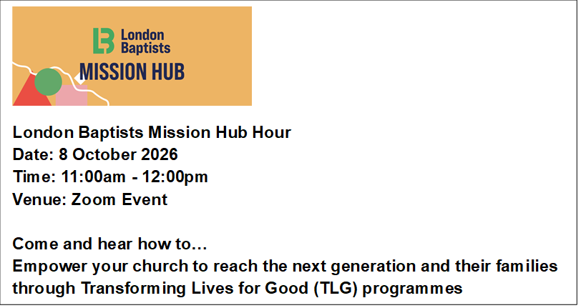
E-mail hany.abdelmasih@londonbapitst.org.uk for more details and to book.

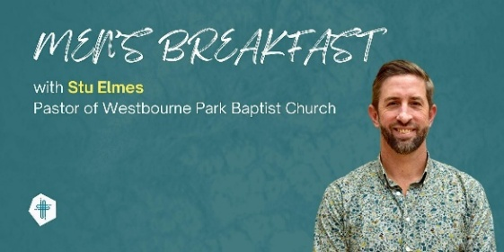

Men's Breakfast with Stu Elmes
Pinner Baptist Church, Saturday 10th October 9-11am.
Come and enjoy breakfast and hear from Stu Elmes how to lead and sustain a faith-filled life in a world of distraction.
For more information and to book your ticket (£10 per person). Book on Eventbrite.



Saturday October 17th, 2026, at 2pm at Westbourne Park Baptist Church.
We will gather to worship and to celebrate what is happening across the Association and our member churches.
The preacher will be Rev Wale Hudson-Roberts, Justice Enabler for the Baptist Union and minister of John Bunyan Baptist Church, Oxford.
The agenda is on the noticeboard in the foyer.

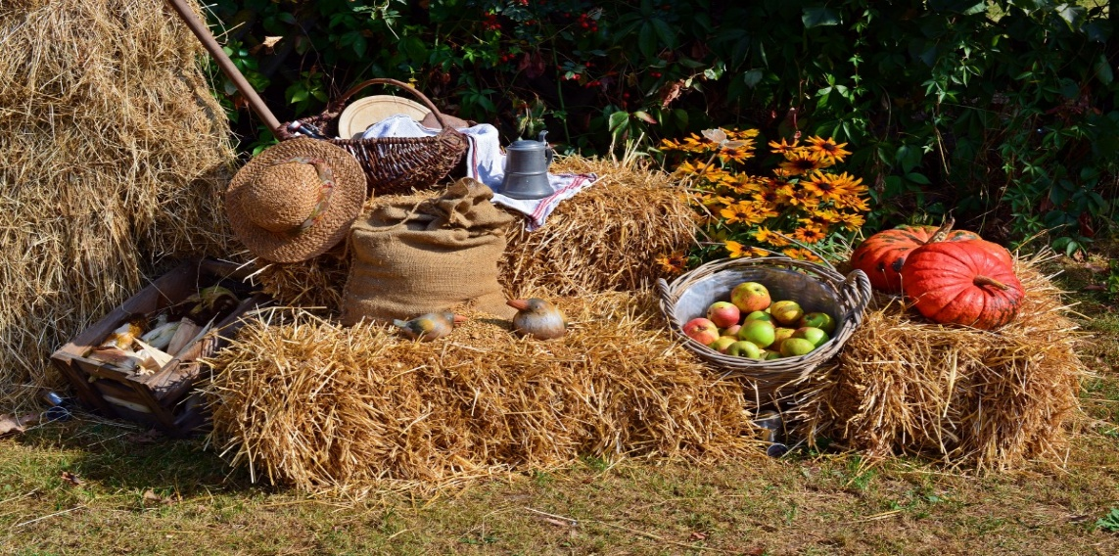


Welcome to
Willesden Green Baptist Church

Harvest Sunday
4th October 2026

Services: 11am and 6.30pm

Weekly Meetings
Tuesdays – 7.30pm – 9pm – Bible Study and Prayer Meeting led by Andrea Marc.
Tuesdays – 7.30pm – 9pm – Bible Study and Prayer Meeting led by Elizabeth Amenuvor (Bi-weekly)
Thursdays – 1.30pm – 3.30pm – Thursday Bible Study led by Janice Carrington.
Thursdays – 6.30pm – 8pm – Corporate Prayer Meeting and Bible Study.
Fridays – 5pm to 7pm every two weeks - Open House. Next session: 16th October 2026.
Saturdays - 13:00 to 15:00 – Gospel Café. Led by Bro Emmanuel Mpaka.

Church Secretary: Lorna Anderson-Edwards
Church Treasurer: Les Ale
Church Administrator: Deborah Hayward
Minister in Training: Pastor Eyasu Seare
Church Office: 020 8451 4951
Website: www.wgbc.london Email: office@wgbc.london Charity Number: 1135448
Willesden Green Baptist Church, 94 High Road Willesden Green, NW10 2PR

Autumn Term
Theme: Power in the Knowledge of God Part 2
Text: “His divine power has granted to us all things that pertain to life and godliness, through the knowledge of Him who called us to His own glory and excellence”.
2 Peter 1: 3

October Theme: A People of the Follower of God
Today, 4th October, is our Harvest service. The theme will be “God’s Abundant Provision and Generosity”.
Bible Reading: Psalm 67 read by Sharon Thompson-Davis
Preacher: Dr Lawrence Akwetey
Worship Leader: The Cherubs
Service Leader: Pedro Baptista
There will be an additional collection for Home Mission during the service. The main collection will be for Harvest.

Next week, 11th October, the theme will be “A Spirit of Sonship”.
Bible Reading: Romans 8: 10 – 17 read by Norma Jones
Preacher: Pastor Pedro
Worship Leader: The Seraph Choir
Service Leader: Bunmi Oguntunde

Our Bank Details for Tithes and Offerings
Bank: The Co-operative Bank
Account Name: Willesden Green Baptist Church.
Account No: 6736 0194 Sort Code: 08-92-99. Please quote GAxxx as your reference (where xxx represents your three-digit gift aid number). If you don’t have a Gift Aid number, please contact the Treasurer, Les Ale on 07940 537418 or via e-mail at church_treasurer@wgbc.london

Sunday Service audios To receive a recording of the service on your mobile phone contact Bro Emmanuel on 07956 484808 and ask him to add your name to the WhatsApp list.

Deacons urgently needed. The next deacons’ elections are in November. Nomination forms are available from Sis Lorna Anderson-Edwards (The Church Secretary) and on the table in the foyer. Please remember to get the permission of the person you wish to nominate. Think and pray about this constantly.

Volunteers Needed
- Volunteers are urgently needed for stewarding and other roles. Contact the church office.

The church office is open from 10am to 3pm Monday to Friday.

Fellowship News
Please continue to pray for those struggling with illness especially: -
Sisters: Lydia B, Edna B, Marie B, Bunmi B, Cynthia C, Melva F, Dorothy G, Marjorie G; Mavis H, Cloeadene K, Daphne M; Comfort O; Betty O-T, Ethel P, Sheilah P, Sandra W; Brothers Ebenezer A, Vernal B, Ron C, Winston E, Eric McL, Herbert T, Hubert J, Bro Carlos.

Please contact members who you have not seen in church for some time. If you do not have their telephone number, or would like a pastoral visit yourself, please contact the church office.
Please pray for …
*The church in this time of transition.
*The leadership of this church, as they progress through the recruitment process for a new minister.
*All who have been bereaved recently.
*Okiki Okunola, as he is currently in hospital. He is getting better and hopes to be discharged very soon.


To all celebrating a birthday or anniversary this month, we pray God’s abundant blessings over you and wish you a very special day.

Forthcoming Events
Harvest Fellowship Meal – after the service today.
Member’s Meeting – 11th October 2026
London Baptists AGM – 17 October 2026 (more information on back of sheet)
Cricklewood Baptist Church 119th Anniversary Celebration followed by lunch – Sunday 18th October 2026 from 11am. You are encouraged to wear your national dress. Tel: 020 8208 1463 or e-mail admin@cricklewoodbc.org to let them know you are coming for catering purposes. See poster on the notice board for more details.
Deacons Meeting – 25 October 2026

If you want to borrow any item from the church, please ask one of the Deacons for permission. Then contact the Church Administrator. Failure to do will result in you being charged the full market value.

