London Baptists Events

This Photo by Unknown Author is licensed under CC BY-NC

Community Fun-Filled Day
To celebrate 95 years of Kingsbury Baptist Church
Bring the whole family and enjoy a day in the sun filled with fun, laughter, and community spirit

Date: 5th September 2026
Time: 2pm
Venue: Kingsbury Baptist Church
Slough Lane,NW9 8QG

Arts and Crafts| Fitness and games| Kid’s activities| Food stalls| Fun prizes

Contact secretary@kingsburybc.uk for more information

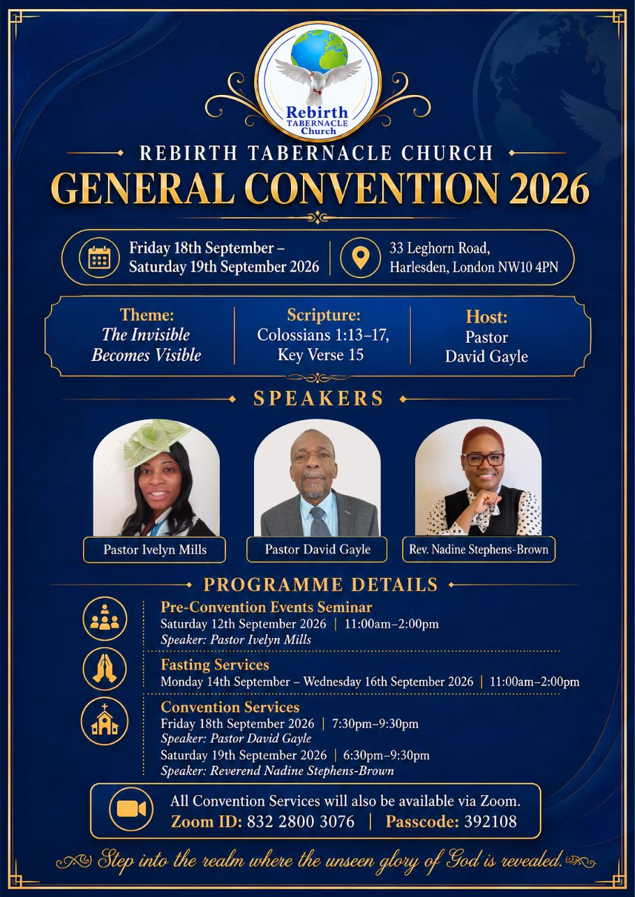


Welcome to
Willesden Green Baptist Church

Sunday 23rd August to 30th August 2026
Services: 11am and 6.30pm

Weekly Meetings
Tuesdays – 7.30pm – 9pm – Bible Study and Prayer Meeting led by Andrea Marc. They are on their summer break and recommence on 8th September.
Tuesdays – 7.30pm – 9pm – Bible Study and Prayer Meeting led by Elizabeth Amenuvor (Bi-weekly)
Thursdays – 1.30pm – 3.30pm – Thursday Bible Study led by Janice Carrington. They are on their summer break and recommence on 17th September 2026.
Thursdays – 6.30pm – 8pm – Corporate Prayer Meeting and Bible Study.
Fridays – 5pm to 7pm every two weeks - Open House. They are on their summer break and recommence on 5th September 2026.
Saturdays - 13:00 to 15:00 – Gospel Café. Led by Bro Emmanuel Mpaka.

Church Secretary: Lorna Anderson-Edwards
Church Treasurer: Les Ale
Church Administrator: Deborah Hayward
Church Office: 020 8451 4951
Website: www.wgbc.london Email: office@wgbc.london Charity Number: 1135448
Willesden Green Baptist Church, 94 High Road Willesden Green, NW10 2PR

Summer Term
Theme: Power in the Knowledge of God
Text: “His divine power has granted to us all things that pertain to life and godliness, through the knowledge of Him who called us to His own glory and excellence”.
2 Peter 1: 3

August Theme: Dealing with Deception

Today, 23rd August, the theme will be “Restored, Strong, Firm and Steadfast”
Bible Reading: John 15: 19 – 25 read by Adesuwa Idahosa
Preacher: Dr Lawrence Akwetey
Worship Leader: The Janice Team
Service Leader: Janice Carrington

Next week, 30th August, the theme will be “Satan’s Strategy of Delusion”
Bible Reading: John 8: 42 – 59 read by Sydney Devis
Preacher: Bro Edward Boamah
Worship Leader: The Seraph Choir
Service Leader: Lorna Anderson-Edwards

Our Bank Details for Tithes and Offerings
Bank: The Co-operative Bank
Account Name: Willesden Green Baptist Church.
Account No: 6736 0194 Sort Code: 08-92-99. Please quote GAxxx as your reference (where xxx represents your three-digit gift aid number). If you don’t have a Gift Aid number, please contact the Treasurer, Les Ale on 07940 537418 or via e-mail at church_treasurer@wgbc.london

Sunday Service audios To receive a recording of the service on your mobile phone contact Bro Emmanuel on 07956 484808 and ask him to add your name to the WhatsApp list.

Deacons needed. If you know God is calling you to serve Him as a deacon, please contact Sis Lorna Anderson-Edwards (The Church Secretary) for more details and how to be nominated.
Volunteers Needed
- Volunteers are needed for stewarding and other roles. Contact the church office.

- If you want to borrow any item from the church, please ask one of the Deacons for permission. Then contact the Church Administrator. Failure to do will result in you being charged the full market value.

The church office is closed until Monday 7th September at 10am. If the matter is urgent, please contact the Church Secretary, Lorna Anderson-Edwards, at secretary@wgbc.london or telephone 020 8451 4951.
Fellowship News
Please continue to pray for those struggling with illness especially: -
Sisters: Lydia B, Edna B, Marie B, Bunmi B, Cynthia C, Melva F, Dorothy G, Marjorie G; Mavis H, Cloeadene K, Daphne M; Comfort O; Betty O-T, Ethel P, Sheilah P, Sandra W; Brothers Ebenezer A, Vernal B, Ron C, Winston E, Eric McL, Herbert T, Hubert J, Bro Carlos.

Please contact members who you have not seen in church for some time. If you do not have their telephone number, or want a pastoral visit yourself, please contact the church office.
Please pray for …
*The church in this time of transition.
*The leadership of this church, as they progress through the recruitment process for a new minister.
*All who have been bereaved recently.
*The family and friends of Sis Comfort Akindiji who died on 18th July 2026. May her soul rest in God’s eternal peace. Details of the funeral will be circulated when received.


To all celebrating a birthday or anniversary this month, we pray God’s abundant blessings over you and wish you a very special day.

Forthcoming Events
Student Service – Sunday 6th September 2026. We will be praying for all students during the service.
Deacons Meeting: 20th September 2026
Harvest Fellowship Meal – 4th October 2026
Members Meeting – 11th October 2026
London Baptists AGM - Saturday 17th October 2026 at 2pm at Westbourne Park Baptist Church. More details coming soon.

