London Baptists Events

London Baptists AGM
Saturday October 17th 2026 at 2pm at Westbourne Park Baptist Church.
More details coming soon.

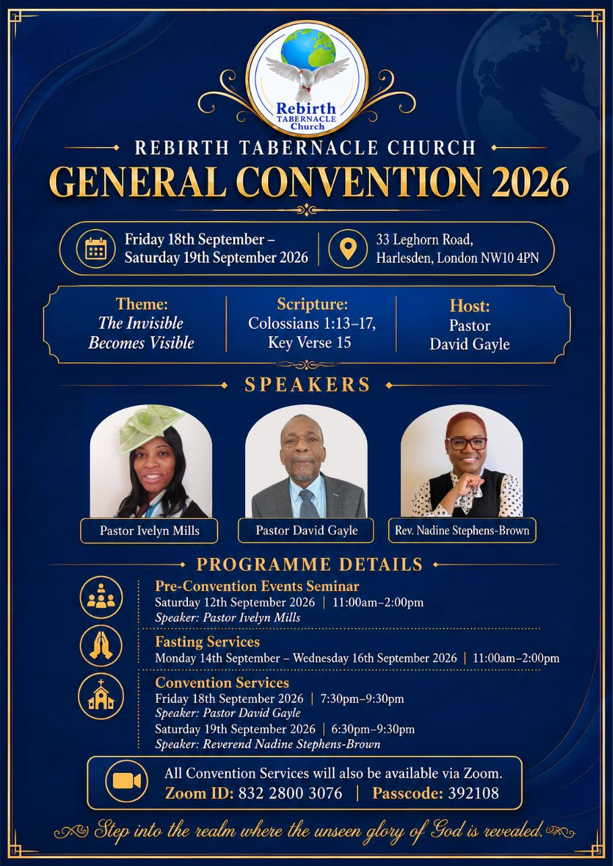



Welcome to
Willesden Green Baptist Church

Sunday 6th September 2026
Student Service
Services: 11am and 6.30pm

Weekly Meetings
Tuesdays – 7.30pm – 9pm – Bible Study and Prayer Meeting led by Andrea Marc. They are on their summer break and recommence on 8th September.
Tuesdays – 7.30pm – 9pm – Bible Study and Prayer Meeting led by Elizabeth Amenuvor (Bi-weekly)
Thursdays – 1.30pm – 3.30pm – Thursday Bible Study led by Janice Carrington. They are on their summer break and recommence on 17th September 2026.
Thursdays – 6.30pm – 8pm – Corporate Prayer Meeting and Bible Study.
Fridays – 5pm to 7pm every two weeks - Open House. They are on their summer break and recommence on 5th September 2026.
Saturdays - 13:00 to 15:00 – Gospel Café. Led by Bro Emmanuel Mpaka.

Church Secretary: Lorna Anderson-Edwards
Church Treasurer: Les Ale
Church Administrator: Deborah Hayward
Church Office: 020 8451 4951
Website: www.wgbc.london Email: office@wgbc.london Charity Number: 1135448
Willesden Green Baptist Church, 94 High Road Willesden Green, NW10 2PR

Autumn Term
Theme: Power in the Knowledge of God
Text: “His divine power has granted to us all things that pertain to life and godliness, through the knowledge of Him who called us to His own glory and excellence”.
2 Peter 1: 3

September Theme: “Penetrating the Enemy Lines”

This Sunday, 6th September, is our annual Student Service. The theme will be “The Devil does not have Dominion”. We will be praying for all who are going to a new school, classroom, college, university or any other further education.
Bible Reading: Ephesians 1: 15 - 23
Preacher: Dr Lawrence Akwetey
Worship Leader: The Cherubs
Service Leader: Pedro Baptista
There will be an additional collection for Home Mission during the service.

Next Sunday, 13th September, the theme will be “Exercising Trust in God”
Bible Reading: Hebrews 3: 14 – 19; 4: 1
Preacher: Pastor Eyasu (MIT)
Worship Leader: The Seraph Choir
Service Leader: Bunmi Oguntunde

Our Bank Details for Tithes and Offerings
Bank: The Co-operative Bank
Account Name: Willesden Green Baptist Church.
Account No: 6736 0194 Sort Code: 08-92-99. Please quote GAxxx as your reference (where xxx represents your three-digit gift aid number). If you don’t have a Gift Aid number, please contact the Treasurer, Les Ale on 07940 537418 or via e-mail at church_treasurer@wgbc.london

Sunday Service audios To receive a recording of the service on your mobile phone contact Bro Emmanuel on 07956 484808 and ask him to add your name to the WhatsApp list.

Deacons needed. If you know God is calling you to serve Him as a deacon, please contact Sis Lorna Anderson-Edwards (The Church Secretary) for more details and how to be nominated.
Volunteers Needed
- Volunteers are needed for stewarding and other roles. Contact the church office.

- If you want to borrow any item from the church, please ask one of the Deacons for permission. Then contact the Church Administrator. Failure to do will result in you being charged the full market value.

Fellowship News
Please continue to pray for those struggling with illness especially: -
Sisters: Lydia B, Edna B, Marie B, Bunmi B, Cynthia C, Melva F, Dorothy G, Marjorie G; Mavis H, Cloeadene K, Daphne M; Comfort O; Betty O-T, Ethel P, Sheilah P, Sandra W; Brothers Ebenezer A, Vernal B, Ron C, Winston E, Eric McL, Herbert T, Hubert J, Bro Carlos.

Please contact members who you have not seen in church for some time. If you do not have their telephone number, or want a pastoral visit yourself, please contact the church office.
Please pray for …
*The church in this time of transition.
*The leadership of this church, as they progress through the recruitment process for a new minister.
*All who have been bereaved recently.
*The family and friends of Sis Comfort Akindiji who died on 18th July 2026. May her soul rest in God’s eternal peace. Details of the funeral will be circulated when received.


To all celebrating a birthday or anniversary this month, we pray God’s abundant blessings over you and wish you a very special day.

Forthcoming Events
Deacons Meeting: 20th September 2026
Harvest Service – 4th October 2026
Harvest Fellowship Meal – 4th October 2026
Member’s Meeting – 11th October 2026
NW London District AGM – 17 October 2026 (more information on back of sheet)
Deacons Meeting – 25 October 2026

The church office is closed from 3pm on Friday 21st August for annual leave and re-opens on Monday 7th September 2026. If the matter is urgent, please contact the Church Secretary, Lorna Anderson-Edwards, at secretary@wgbc.london or telephone 020 8451 4951

